Explainable Identification of Human vs. Large Language Model (LLM) Generated Text: A Systematic Review
JAWWAD AHMAD
Department of Computer Science, The Islamia University of Bahawalpur, Pakistan
Student ID: F25NDOCS3W04013 | MSCS 2nd Semester
Supervisor: Dr. Ahmad Niaz, Assistant Professor, Computer Science Department

Abstract—The rapid proliferation of Large Language Models (LLMs) such as GPT-4, Llama, Claude, and Google Gemini has intensified the need for reliable automated detection of machine-generated text across high-stakes domains including academia, journalism, and medicine. While transformer-based detection systems have achieved state-of-the-art classification accuracy, their opaque decision-making processes undermine user trust and institutional accountability. This review addresses that limitation by systematically examining the intersection of AI-generated text detection and Explainable Artificial Intelligence (XAI), focusing on the post-hoc local explanation methods LIME (Local Interpretable Model-agnostic Explanations) and SHAP (SHapley Additive exPlanations). Following the PRISMA framework, a systematic search of four electronic databases yielded twelve studies published between 2023 and 2026. Findings are synthesized across three thematic clusters stylometric and classical machine learning approaches, transformer-based deep learning methods, and multi-label attribution frameworks and analyzed against four research questions. The review's principal positive finding is convergent validity: LIME and SHAP consistently identify grammatical standardization, formulaic transitional language, low lexical entropy, and suppressed epistemic hedging as the most discriminative markers of LLM authorship, regardless of the underlying detection architecture. The review also documents an unresolved adversarial paradox and identifies five structural research gaps spanning adversarial robustness, XAI evaluation standards, fairness for non-native writers, cross-domain generalization, and multilingual coverage.
Index Terms—AI-generated text detection, explainable artificial intelligence, LIME, SHAP, large language models, stylometry, transformer models, natural language processing, systematic literature review.

I. Introduction
The emergence of Large Language Models (LLMs) such as GPT-4, Llama, Claude, and Google Gemini has redefined the boundaries of automated text generation. These systems produce output that is grammatically fluent, contextually coherent, and stylistically indistinguishable from human prose—a capability that introduces serious risks across academic, journalistic, legal, and medical contexts. As a result, automated detection of AI-generated text has emerged as one of the most pressing challenges in contemporary Natural Language Processing (NLP).
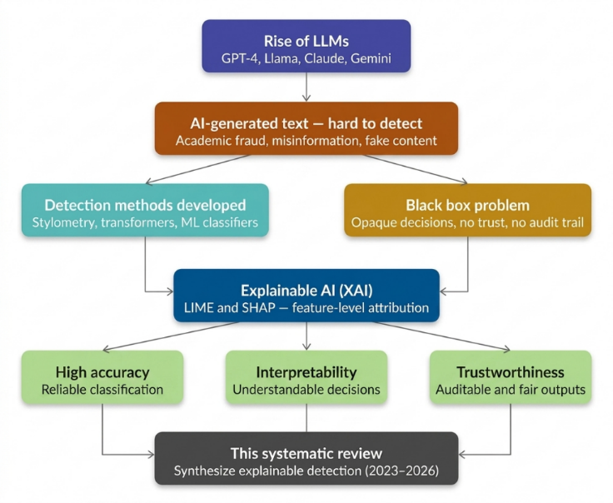
Early detection systems relied on perplexity scores, burstiness metrics, and stylometric indices. These were rapidly eclipsed by transformer-based architectures such as RoBERTa and DistilBERT, which achieved significantly higher classification accuracy. The HULLMI framework [1] demonstrated that fine-tuned transformers could outperform conventional classifiers across multiple LLM sources and domains. However, improved accuracy has in many ways compounded the underlying challenge.
Transformer-based detectors operate as "black boxes" arriving at decisions through internal representations inaccessible to end-users. An educator cannot discipline a student, a journal cannot reject a manuscript, and a legal body cannot challenge evidence on the basis of a system whose reasoning is opaque. The field has therefore turned toward Explainable Artificial Intelligence (XAI) as an essential complement to detection performance.
Two post-hoc local explanation methods have gained traction: LIME (Local Interpretable Model-agnostic Explanations) [2] and SHAP (SHapley Additive exPlanations) [3]. Both are model-agnostic and provide feature-level attribution, enabling users to understand which linguistic properties drove a classification decision. Studies such as [4] and [5] demonstrate that LIME and SHAP can surface meaningful patterns grammatical standardization, atypical word frequency distributions, punctuation anomalies that consistently distinguish AI-generated from human-written text. Najjar et al. [6] further showed that XAI feature profiles can attribute text to specific LLMs, moving the field toward richer multi-label attribution.
Figure 1: Classification of XAI approaches. Methods are divided into local vs. global scope and ante-hoc vs. post-hoc timing, with a primary emphasis on model-agnostic tools such as LIME and SHAP for individual prediction interpretation.
Despite this progress, the literature remains fragmented across detection architectures, datasets, explainability methods, and domains. No comprehensive synthesis currently maps the full landscape of explainable AGTD across multiple LLMs, text domains, and XAI methodologies. This paper addresses that gap through a PRISMA-guided Systematic Literature Review (SLR), synthesizing research published between 2023 and 2026.
II. Background and Preliminaries
A. Large Language Models and Text Generation
Large Language Models are deep neural networks trained on vast text corpora to model the statistical structure of natural language. Built on the transformer architecture, modern LLMs such as GPT-4, Llama 3, Claude, and Google Gemini use self-attention mechanisms to capture long-range syntactic and semantic dependencies. Text generation is an autoregressive process: the model computes a probability distribution over its vocabulary and samples the next token iteratively. The temperature parameter governs output diversity. LLM-generated text tends toward grammatical standardization and high lexical predictability signals stylometric studies have identified as consistent markers of machine authorship [7], [8].
B. AI-Generated Text Detection (AGTD)
AGTD involves automatically classifying text as human-authored or machine-generated, or attributing it to a specific LLM source [6], [9]. The literature organizes detection approaches into three paradigms. Stylometric and classical ML methods use handcrafted linguistic features syllable counts, POS distributions, readability indices fed into SVM or Logistic Regression classifiers. These are interpretable but limited in capturing deep contextual patterns [4], [7]. Transformer-based methods fine-tune models like RoBERTa and DistilBERT for high accuracy but sacrifice interpretability. Multi-label attribution and ensemble methods combine architectures to identify not just whether text is AI-generated, but which LLM produced it [10], [11].
Three benchmark datasets dominate the reviewed literature: HC3 (Human-ChatGPT Comparison Corpus) for binary classification; M4 for cross-lingual, multi-LLM evaluation; and HULLMI [1], purpose-built for explainability-focused detection across multiple LLM sources.
Table 1: Benchmark Datasets used across Reviewed Studies
Dataset | Source | Coverage | Use
HC3 | Human + ChatGPT | Multi-domain, EN | Binary classification
M4 | Human + multi-LLM | Multilingual,  Multimodel | Generalization
HULLMI | Human + GPT/Llama | Multi-source, EN | XAI evaluation
C. Explainable Artificial Intelligence (XAI)
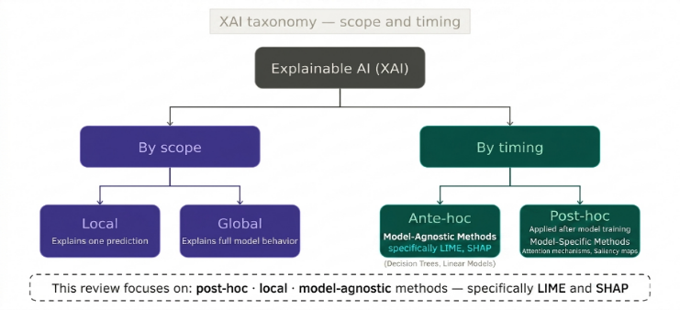
XAI refers to methods and principles that make ML model decisions understandable to human users. XAI methods are categorized by scope (local vs. global) and timing (ante-hoc vs. post-hoc). Post-hoc local methods have proven most practical for AGTD, allowing interpretability to be layered onto high-performing transformer models without sacrificing accuracy [1], [5]. This review focuses specifically on post-hoc, local, model-agnostic methods—LIME and SHAP.
Figure 2: Conceptual framework of the systematic review (2023–2026), illustrating the transition from the black-box challenges of LLM-generated text to interpretable and trustworthy detection via XAI.
D. LIME: Local Interpretable Model-Agnostic Explanations
LIME [2] explains individual predictions by approximating a classifier's decision boundary locally with a simpler interpretable model. In text classification, LIME perturbs input by systematically masking words and observes how predictions change. A weighted linear model is fitted to this perturbation dataset, and its coefficients are reported as feature importances. Applied to AGTD, LIME identifies which tokens most strongly push the classifier toward an "AI" verdict.
E. SHAP: SHapley Additive Explanations
SHAP [3] is grounded in cooperative game theory. Each feature is treated as a "player" contributing to a joint outcome, and Shapley values quantify each feature's marginal contribution across all possible feature subsets. SHAP values are additive and consistent—summing token-level values yields exactly the model's predicted probability. Positive values indicate a push toward AI-generated; negative values toward human authorship.
F. LIME vs. SHAP: Key Differences
Both methods are post-hoc, local, and model-agnostic. LIME is faster and more flexible but can be unstable across runs due to random perturbation sampling. SHAP produces consistent, reproducible explanations grounded in mathematically guaranteed fair attribution but at significantly higher computational cost. In the reviewed literature, LIME is more commonly paired with transformer detectors where speed matters, while SHAP is preferred in stylometric settings requiring rigorous feature ranking [4], [5], [12].
III. Methodology
A. PRISMA Framework
This review adopts a Systematic Literature Review (SLR) methodology a structured, reproducible approach to synthesizing research evidence that minimizes selection bias and maximizes transparency guided by PRISMA (Preferred Reporting Items for Systematic Reviews and Meta-Analyses) which provides a standardized checklist and flow structure for documenting each stage of the review process. PRISMA ensures that the selection of twelve included studies is traceable, auditable, and reproducible [10].
B. Search Strategy
Four electronic databases were systematically searched: Google Scholar, ArXiv, IEEE Xplore, and SciSpace. Primary search strings included: "LLM text detection" AND "explainable AI"; "human vs AI text" AND "LIME OR SHAP"; "AI-generated text detection" AND "interpretability"; "transformer text classification" AND "feature attribution"; and "stylometry" AND "LLM detection".
C. Inclusion and Exclusion Criteria
Inclusion required all four conditions: (1) published between January 2023 and March 2026; (2) directly addresses AGTD or attribution; (3) incorporates at least one explainability method; (4) written in English. Papers were excluded if they focused on non-textual modalities, used datasets below 500 samples, or lacked clearly reported evaluation metrics.
D. PRISMA Flow
The selection pipeline proceeded as follows: 250 records identified across four databases (Google Scholar: 120; ArXiv: 72; IEEE Xplore: 38; SciSpace: 20). After removing 68 duplicates, 182 records were screened; 126 excluded at title/abstract stage. Of 56 full-texts assessed, 44 were excluded: no formal XAI method (n=18), dataset below 500 samples (n=12), non-English text (n=8), no standard evaluation metric (n=6). Twelve studies included in the final synthesis.
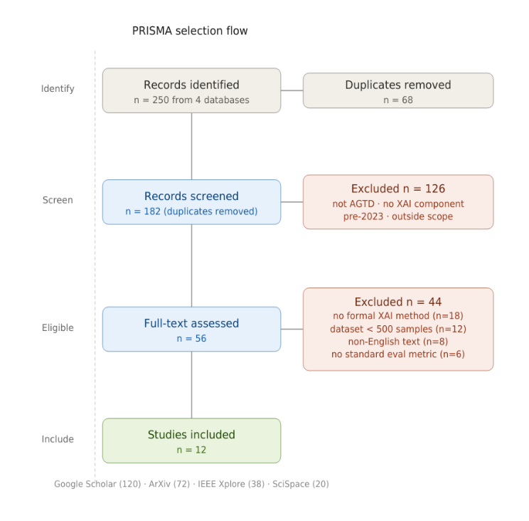
Figure 3: PRISMA flow diagram showing the complete paper selection pipeline from 250 initially identified records across four databases to the 12 studies included in the final systematic synthesis, with exclusion reasons and counts at each stage.
E. Data Extraction
For each included study, data were extracted using a standardized template recording: detection architecture; explainability method; dataset(s) and sample size; evaluation metrics; primary discriminative linguistic features identified by XAI; and reported limitations. This template is reflected in the comparative tables presented in Sections 4 and 5.
F. Quality Assessment
Each study was evaluated against four CASP-adapted criteria: (1) publication in a peer-reviewed venue; (2) dataset ≥500 samples; (3) at least one standard evaluation metric; (4) availability of replication materials. All twelve final studies satisfy at least three of the four criteria.
IV. Literature Review and Thematic Analysis
The twelve included studies are organized into three thematic clusters. Studies are analyzed along four consistent axes: detection architecture, XAI method, discriminative linguistic features, and key limitations.
A. Theme 1: Stylometric and Classical ML Approaches
The earliest and most interpretable strand of AGTD relies on stylometry quantitative analysis of writing style through handcrafted linguistic features combined with conventional classifiers. Three studies fall within this cluster: Shah et al. [4], McGovern et al. [7], and Przystalski et al. [8].
Shah et al. [4] train SVM, Logistic Regression, and Random Forest classifiers on a rich feature set including syllable count distributions, punctuation frequency ratios, lexical diversity indices (Simpson's Index), average word length, and sentence length variance. Both LIME and SHAP reveal that formulaic transitional phrases and low-entropy word choices are the strongest positive predictors of AI authorship. Simpson's Index and punctuation regularity emerge as the two most consistently discriminative dimensions across all three classifiers. The convergence of both methods on the same underlying signal, despite using fundamentally different attribution mechanisms, substantially strengthens confidence in the finding.
McGovern et al. [7] investigate model-specific stylistic fingerprints across GPT-3.5, GPT-4, Llama, and several smaller models, showing that each LLM exhibits a characteristic POS tag distribution and high-frequency token profile stable enough to constitute a reliable authorial signature. LLMs consistently over-represent adjective-noun sequences and passive constructions directly actionable for detection system design.
Przystalski et al. [8] address short text samples (fewer than 200 words). SHAP global importance rankings identify three dominant features: grammatical standardization, atypical word frequency distributions, and lexical entropy. Grammatical standardization accounts for nearly twice the predictive weight of the next most important feature the most technically rigorous finding in Theme 1.
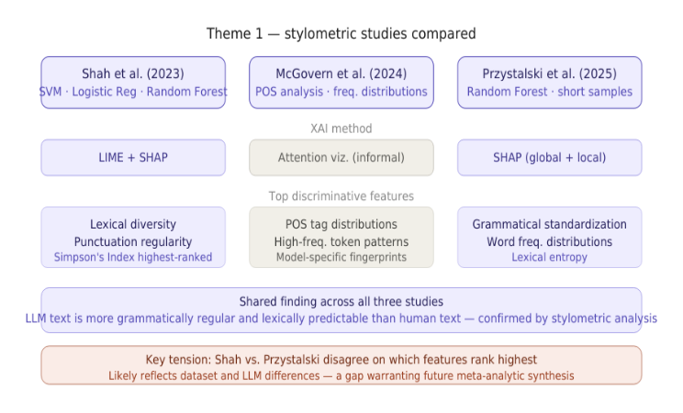
Figure 4: Comparison of the three Theme 1 stylometric studies (Shah et al., 2023; McGovern et al., 2024; Przystalski et al., 2025) across detection method, XAI tool applied, top discriminative features identified, and key shared finding versus unresolved tension.
B. Theme 2: Transformer-Based Deep Learning Methods
The second cluster encompasses four studies applying fine-tuned transformer architectures, each incorporating post-hoc XAI to recover interpretability. This cluster is defined by a fundamental tension: transformers achieve substantially higher accuracy than stylometric methods, but their internal representations are far more difficult to interpret.
Mitrovic et al. [12] fine-tune DistilBERT on a balanced dataset of human-written and ChatGPT-generated short reviews (~50 - 150 words), achieving substantially higher classification accuracy than traditional ML baselines. SHAP applied at the token level reveals that ChatGPT-generated reviews consistently over-produce evaluative superlatives ("exceptional", "outstanding", "perfect"), generic positive sentiment constructions, and formulaic closing phrases. Human reviews exhibit idiosyncratic vocabulary, hedged evaluations, and topic-specific references the model recognizes as authentically personal.
The HULLMI framework [1] is the most architecturally comprehensive study in this review. RoBERTa-Sentinel achieves ~91% classification accuracy across all evaluated conditions. Integrating LIME into this pipeline does not degrade performance but adds token-level transparency. LIME explanations reveal that the model's highest-confidence predictions are driven by formulaic hedging language, impersonal constructions, and overly smooth discourse transitions—rather than spurious correlations or dataset artifacts. This positions explainability as a complement to accuracy rather than a trade-off. Accuracy varies considerably across LLMs: models trained primarily on GPT-generated text show 8-14 percentage-point drops when applied to Llama-generated text.
Masih et al. [5] provide the most comprehensive side-by-side comparison of LIME and SHAP applied to transformer-based text detection, covering BERT, RoBERTa, and a fine-tuned GPT-2 classifier on a mixed corpus. SHAP produces more stable and reproducible explanations than LIME. Both methods can expose cases where a model is correct for the wrong reasons where high classification confidence is driven by domain-specific vocabulary or topic signals rather than authentic stylistic markers of AI authorship.
Mohammadi et al. [13] expose a critical vulnerability: XAI-informed token replacement reduces detection accuracy by 20-35 percentage points on average, with minimal degradation in semantic coherence. This exposes an "explainability paradox" the transparency that makes detection systems trustworthy simultaneously makes them vulnerable to informed adversarial manipulation. No practical defense mechanism is proposed.
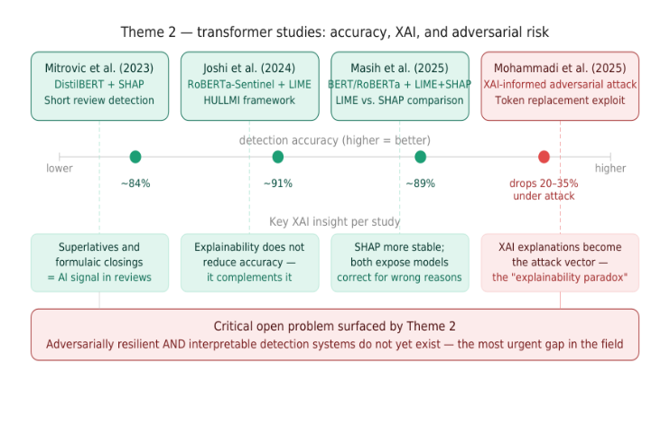
Figure 5: Theme 2 transformer-based studies compared across detection accuracy, key XAI insight per study, and the adversarial paradox revealed by Mohammadi et al. (2025), in which XAI explanations simultaneously enable auditing and targeted evasion
C. Theme 3: Multi-Label Attribution and Cross-Domain Generalization
The third cluster moves beyond binary classification toward identifying which specific LLM produced a text. XAI plays a qualitatively different role here not merely as a transparency mechanism, but as a core analytical tool for constructing author identity profiles.
Adilazuarda et al. [10] conduct a systematic comparative analysis across multiple benchmark datasets including multilingual corpora. No single paradigm consistently dominates across domains and languages. Transformer-based methods lead in accuracy on single-domain benchmarks, but their advantage narrows or reverses on cross-domain and multilingual datasets. Stylometric methods generalize more stably across domains.
Najjar et al. [6] demonstrate that XAI feature importance profiles can construct distinct "authorship signatures" for different LLMs. The resulting feature importance profiles are model-specific and stable: GPT-4-generated texts are most strongly flagged by discourse-level coherence features; Llama-generated texts by vocabulary distribution patterns; and Gemini outputs by a characteristic avoidance of hedging language. Notably, Claude-generated texts show the strongest resemblance to human writing by several stylometric measures—a finding with direct implications for the difficulty of detecting outputs from the most capable current LLMs.
Zahraa J. Mohammed Ali [9] combines transformer embeddings with LIME and SHAP in a unified multi-label pipeline. XAI attribution granularity improves substantially at the multi-label level: SHAP surfaces source-specific patterns differentiating GPT-4-generated text from Llama-generated text through fine-grained differences in syntactic complexity and hedging frequency.
Baharifar et al. [14] address LLM-generated medical misinformation detection. SHAP attributions reveal that such misinformation is most reliably distinguished by overuse of confident assertive constructions, avoidance of appropriate epistemic hedging ("may", "suggests", "is consistent with"), and tendency to state statistical claims without numerical precision or source attribution characteristic of genuine clinical literature.
Iqbal and Kashem [11] propose an ensemble ML framework using gradient-boosted classifiers trained on a hybrid feature set combining classical stylometric indices with TF-IDF-weighted lexical representations. Feature importance analysis reveals cross-source attribution relies most heavily on vocabulary distribution divergence, sentence length consistency, and connective phrase frequency.
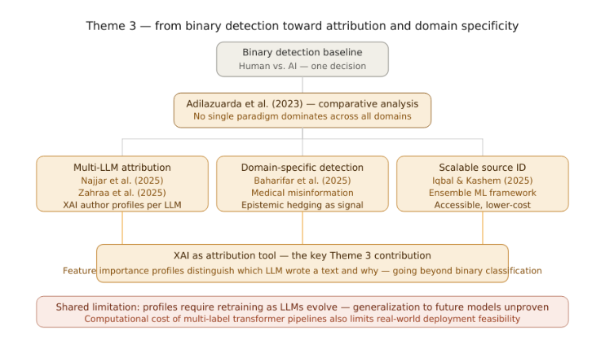
D. Cross-Thematic Synthesis
Figure 6: Theme 3 progression from binary detection (Adilazuarda et al., 2023) toward multi-LLM attribution (Najjar et al., 2025; Zahraa et al., 2025), domain-specific detection (Baharifar et al., 2025), and scalable source identification (Iqbal & Kashem, 2025)
Four consistent patterns emerge across all three themes. First, LIME and SHAP consistently surface the same core linguistic signals grammatical standardization, formulaic transitional language, low lexical entropy, and avoidance of epistemic hedging regardless of detection architecture. Second, explainability and accuracy are complementary, not in tension [1], [5]. Third, no study reports satisfactory cross-domain generalization [10]. Fourth, the adversarial vulnerability documented by Mohammadi et al. [13] remains unresolved.
V. Comparative Analysis and Discussion
A. RQ1: Detection Paradigm Comparison in accuracy and interpretability
Stylometric and classical ML approaches [4], [7], [8] offer the highest baseline interpretability with accuracy in the 80-87% range. Transformer-based approaches [1], [5], [12], [13] achieve peak accuracy (~91% for RoBERTa-Sentinel) but their interpretability deficit is recoverable through LIME and SHAP integration without accuracy sacrifice. Multi-label attribution frameworks [6], [9], [10], [11], [14] produce the richest output at the highest computational cost. No paradigm dominates across all four dimensions of accuracy, interpretability, generalizability, and adversarial robustness.

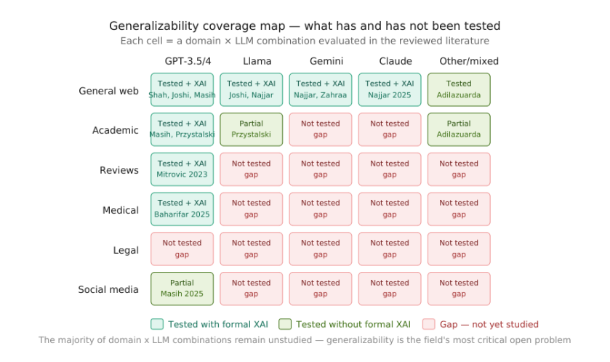
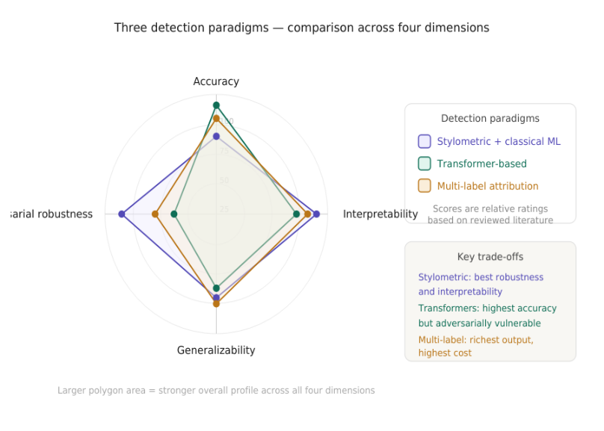
Figure 7: Generalizability coverage map showing which domain-by-LLM evaluation combinations have been studied with formal XAI (teal), studied without formal XAI (green), or remain completely unstudied (coral/red).
Figure 8: Radar chart comparing the three detection paradigms stylometric and classical ML (purple), transformer-based (teal), and multi-label attribution (amber) across four dimensions: accuracy, interpretability, cross-domain generalizability.
B. RQ2: Effectiveness of LIME and SHAP
Across all twelve studies, LIME and SHAP demonstrate consistent ability to surface linguistically meaningful discriminative features the strongest positive finding of this review. Grammatical standardization is the single most consistently reported feature, appearing across all three paradigms in studies using both methods. The convergence across fundamentally different attribution mechanisms constitutes particularly strong evidence of a genuine and stable property of LLM-generated text.

Table 2: Top-Ranked Discriminative Features identified by LIME/SHAP
Feature | Studies | Paradigm
Grammatical standardization | [8],[5],[14] | All three
Formulaic transitional phrases | [4],[1],[9] | Styl., Transf.
Low lexical entropy | [4],[8],[11] | Styl., Ensem.
Superlatives/assertive constructions | [12],[14] | Transformer
Absence of epistemic hedging | [14],[6] | Multi-label
POS tag distribution anomalies | [7],[8] | Stylometric
Discourse coherence over-smoothing | [1],[6] | Transf., Multi-l.

C. RQ3: Generalizability Across Domains and LLMs
Generalizability is the most consistently problematic dimension across the entire reviewed literature. Every study evaluating cross-domain or cross-LLM performance reports significant degradation. For stylometric methods, the failure mode is featuring drift; for transformer-based methods, distributional shift; for multi-label attribution frameworks, model version sensitivity. The entire legal domain has not been evaluated by any study in this review a fundamental limitation on the trustworthiness of current detection systems when deployed outside controlled research conditions.
D. RQ4: Structural Limitations
Four structural limitations emerge. First, adversarial vulnerability: XAI-informed token replacement [13] represents a practically executable attack that is a structural consequence of making detection systems interpretable. Second, absence of standardized XAI evaluation benchmarks, no study applies metrics for explanation faithfulness, stability, or human interpretability. Third, systematic bias risk against non-native English speakers and specialized professional writers whose writing shares stylometric characteristics with LLM output. Fourth, evaluation metric homogeneity the literature relies almost exclusively on accuracy and F1-score, treating all misclassifications equally despite the asymmetric institutional consequences of false positives in AGTD contexts.
VI. Research Gaps and Future Directions
A. Gap 1: Adversarial Robustness
XAI-informed token replacement [13] reduces state-of-the-art detector accuracy by 20-35 percentage points. No current architecture is simultaneously robust against this attack and interpretable. Future research should explore explanation-aware detection architectures models whose training objective explicitly penalizes the ability of explanation-guided perturbations to shift classification output and ensemble-based detection with distributed attribution.
B. Gap 2: Standardized XAI Evaluation Benchmarks
The field lacks shared protocols for assessing XAI faithfulness, stability, and interpretability. The most impactful single contribution would be the development of a shared XAI evaluation protocol for AGTD, analogous to the role GLUE and SuperGLUE play in general NLP. Such a protocol should include automated faithfulness metrics, stability metrics, and human evaluation studies.
C. Gap 3: Fairness for Non-Native and Specialized Writers
The discriminative features most consistently identified by XAI are equally characteristic of non-native English speakers, professionals writing in codified registers, and students writing under examination conditions. No study evaluates false positive rates for these populations a significant ethical gap given the deployment of detection systems in academic integrity contexts globally. Future research should pursue bias audit methodology and explanation-based debiasing.
D. Gap 4: Cross-Domain and Cross-LLM Generalization
Most domain-by-LLM evaluation combinations remain completely unstudied. Three directions are warranted: XAI-guided domain adaptation; meta-learning for detection generalization using few-shot adaptation; and longitudinal evaluation studies tracking detection performance as LLMs evolve.
E. Gap 5: Multilingual Detection with Explainability
None of the twelve reviewed studies applies formal XAI methods to non-English text. Future work should develop multilingual explainable detection benchmarks across typologically diverse languages. The application of LIME and SHAP to multilingual transformer models such as mBERT and XLM-RoBERTa would provide the first systematic characterization of cross-lingual XAI attribution in AGTD.
VII. Conclusion
The detection of LLM-generated text has evolved rapidly from a niche classification problem into one of the most consequential challenges in contemporary NLP. The central argument of this review is that explainability is not an optional enhancement to AGTD it is a prerequisite for trustworthy deployment wherever the stakes of misclassification are real.
This systematic review synthesized twelve studies published between 2023 and 2026 across three thematic clusters, analyzed through the consistent lens of how LIME and SHAP contribute to making detection decisions interpretable, auditable, and fair. The principal positive finding is convergent validity: both methods consistently surface the same core linguistic markers of LLM authorship grammatical standardization, formulaic transitional language, low lexical entropy, and suppressed epistemic hedging.
The principal critical finding is equally clear: the field has not yet reconciled transparency with robustness. The adversarial paradox documented by Mohammadi et al. [13] remains unresolved, and no current architecture achieves both properties together. The five-gap research agenda proposed in this review provides a concrete and prioritized path forward. In a world where LLM-generated content is increasingly embedded in academic, journalistic, medical, and legal discourse, the ability to detect and explain AI authorship transparently is not merely a technical capability it is a governance requirement.
References
[1] P. D. Joshi, S. Pocker, R. A. Dandekar, and S. Panat, "HULLMI: Human vs LLM identification with explainability," arXiv preprint arXiv:2409.04808, 2024.
[2] M. T. Ribeiro, S. Singh, and C. Guestrin, "'Why Should I Trust You?': Explaining the predictions of any classifier," in Proc. 22nd ACM SIGKDD Conf. Knowledge Discovery and Data Mining, 2016.
[3] S. M. Lundberg and S.-I. Lee, "A unified approach to interpreting model predictions," in Proc. Neural Information Processing Systems (NeurIPS), 2017.
[4] A. Shah et al., "Detecting and unmasking AI-generated texts through explainable artificial intelligence using stylistic features," Int. J. Advanced Computer Science and Applications, vol. 14, no. 10, 2023.
[5] A. Masih et al., "Classifying human vs. AI text with machine learning and explainable transformer models," Scientific Reports, vol. 15, no. 1, p. 43310, 2025.
[6] A. A. Najjar, H. I. Ashqar, O. Darwish, and E. Hammad, "Leveraging explainable AI for LLM text attribution," Information, vol. 16, no. 9, p. 767, 2025.
[7] H. McGovern, R. Stureborg, Y. Suhara, and D. Alikaniotis, "Your large language models are leaving fingerprints," arXiv preprint arXiv:2405.14057, 2024.
[8] K. Przystalski, J. K. Argasiński, I. Grabska-Gradzińska, and J. Ochab, "Stylometry recognizes human and LLM-generated texts in short samples," Expert Systems with Applications, p. 129001, 2025.
[9] Z. J. Mohammed Ali, "Interpretable multi-label classification of human- and LLM-generated texts using transformer embeddings and explainable AI," Ingénierie des Systèmes d'Information, vol. 30, no. 12, 2025.
[10] F. Adilazuarda, N. N. Arkoulis, and O. Chumakov, "Beyond Turing: A comparative analysis of approaches for detecting machine-generated text," arXiv preprint arXiv:2311.12373, 2023.
[11] M. S. Iqbal and M. A. Kashem, "A machine learning framework for identifying sources of AI-generated text," Statistics, Optimization & Information Computing, vol. 13, no. 5, pp. 2186–2204, 2025.
[12] S. Mitrovic, D. Andreoletti, and O. Ayoub, "ChatGPT or Human? Detect and explain," arXiv preprint arXiv:2301.13852, 2023.
[13] H. Mohammadi, A. Giachanou, D. L. Oberski, and A. Bagheri, "Explainability-based token replacement on LLM-generated text," arXiv preprint arXiv:2506.04050, 2025.
[14] M. Baharifar, A. Kujur, and Z. Monfared, "Interpretable AI for classifying human- and LLM-generated medical misinformation with multi-modal features," 2nd Sorbonne-Heidelberg Workshop on AI in Medicine, 2025.

